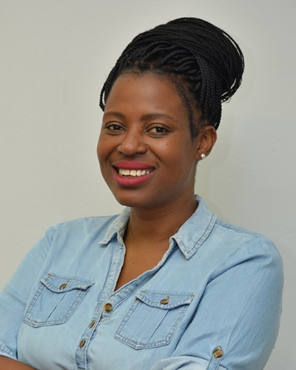Dr Moreblessings Shoko is a rated researcher and academic scholar at the University of Cape Town in South Africa. She is also the CEO and Founder of Drone Wings Pvt Ltd in Zimbabwe which offers UAV and Geospatial Consultancy Services. Moreblessings holds BSc, MSc, an MBA, and PhD qualifications, with a focus on Geomatics and its related sub-disciplines. Her research interests span over professional and built environment transformation through using 4iR technologies in updating the changing role of Geomatics practioners in contemporary discourse.

Her professional and career highlights include being a current member of the FIG Standards sub-committee on Surveying by Drones and the working group on Land Administration Education. Shoko is also past President of the Zimbabwe Institute of Geomatics, a laurette of the prestigious Marina van Damme Network and a business mentor on the continent-wide Women in Africa Initiative (Technology mentorship category). She was selected and featured on an international art piece for depiction in a diversity campaign in 2022 at the University of Twente in 2022 based on her active role as an alumnus of the ITC. She also won the Africa Drone Conference grant in 2020 and was also one of Africa’s first civil aviation registered female drone pilots. She is a member of the International Society of Photogrammetry and Remote Sensing, South African Drone Council, and a Board Member of several socially responsive technological initiatives. In 2022, Moreblessings was awarded the Contributor of the year recognition (for UAV/Photogrammetry) by the Zimbabwean Institute of Geomatics.

Adventure, challenges, and disruptive technologies have always been something she loved. It is therefore no surprise, that her interests have paved a path of championing professional transformation and pushing the edge, around disruptive technologies like reality capture, LiDAR, base data in BIM , drones, and their role in contemporary geo-spatial data capture.